INTEGRATIVE COURSE IN PSYCHOLOGY (ICOPSYCH)
ANALYSIS ON THE RESULT OF POST-TEST EXAMINATION IN ABNORMAL PSYCHOLOGY
APRIL 12, 2025

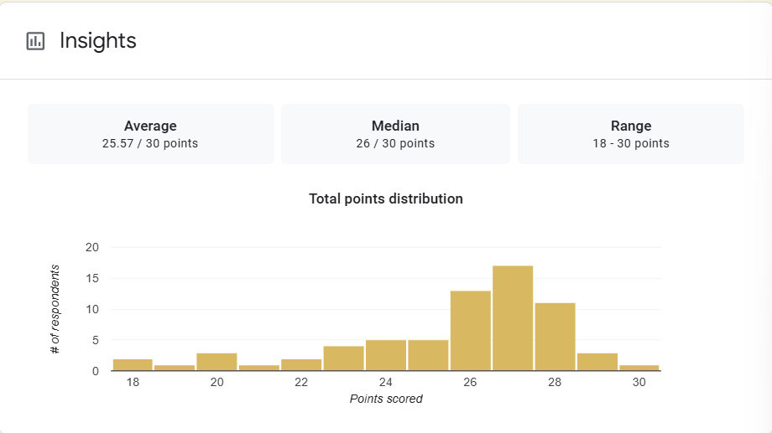

1. Mean Score: The average score is 25.57, which translates to approximately 85.2%, a strong overall performance. This suggests that most participants had a good grasp of the material or performed well on the test.

2. Median Score: The median score is 26, slightly higher than the mean. This means that at least half the participants scored 26 or higher.
3. Range: The scores span from 18 to 30, which is a range of 12 points. Even the lowest score (18/30 = 60%) is still a passing or average score in many grading systems, indicating that all participants performed at least moderately well, with no extreme underperformance.
Interpretation Summary:

-Overall performance was strong, with both the mean and median above 85%.
-The slightly left-skewed distribution implies that while most did very well, a few lower scores may have influenced the average.
-The range of scores is relatively narrow, showing consistency in performance and suggesting a fairly uniform level of understanding among test takers.

RATIONALIZATION:

DIFFICULT QUESTIONS:

